Kilbarchan aac
Version 0.1
Season 2019-20
Code of Conduct Parent/Carer

As a responsible parent/carer I will:

- Demonstrate respectful behaviour at all times

- Set a good example and encourage my child to learn the rules of the sport and compete within them at all times

- Help my child to recognise good performance, and not just results

- Make athletics fun

- Never force my child to take part in sport if they do not want to

- Never punish or belittle my child for losing or making mistakes

- Use appropriate language at all times

- Check the qualifications and licences of people who are coaching, managing or offering a service such as physiotherapy, massage or nutritional advice to my child

- Know where my child will be and who they will be with at all times

- Assume responsibility for safe transportation of my child to and from training and competition

- Return any necessary written consent forms to the club/team manager prior to trips or competitions, as necessary

- Provide any necessary medication required by my child for training or trips away

- Report any concerns about my child’s (or any other child’s) welfare to the Club Welfare Officer or National Welfare Officer. (This does not affect your right to contact social services or the police if you feel it is necessary)

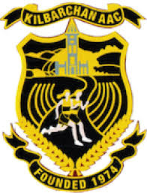
- I understand that inappropriate pressure on children and poor behaviour of adult spectators can sometimes make children drop out of sport. I accept that this code promotes good spectator behaviour. I understand that if I verbally abuse children, coaches or officials action will be taken.

