Kilbarchan aac
Version 0.1
Season 2019-20
Code of Conduct Senior Athletes

As a member of Kilbarchan AAC you agree to abide by the following code of conduct:
- Treat others with the same respect and fairness that you wish to receive

- Display courtesy and good manners towards others

- uphold the same values away from the sport as you do when engaged in athletics

- Participate within the rules of the sport, respect decisions of coaches and officials and demonstrate respect towards fellow athletes

- inform your coach of any other coaching you are receiving

- Cooperate fully with others involved in the sport such as coaches, technical officials, team managers, doctors, physiotherapists and representatives of the governing body in the best interests of yourself and other athletes

- Consistently promote positive aspects of the sport and never condone rule violations or the use of prohibited substances

- Anticipate and be responsible for your own needs including being organised, having the appropriate equipment and being on time

- Avoid swearing and abusive language while in athletic venues, at club functions or events or when part of a team or squad

- Never engage in any inappropriate or illegal behaviour

- Challenge and report any inappropriate behaviour or language by others

- Not misuse or abuse sporting equipment or venues

- Not carry or consume alcohol or illegal substances

- Maintain strict boundaries between friendship and intimacy with a coach or official

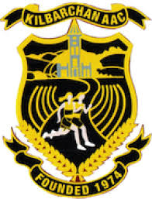
- I understand that any breach of the Code of Conduct may result in sanctions as outlined in the Club Grievance Procedure

