Kilbarchan aac
Version 0.1
Season 2018-19
Kilbarchan AAC Competition Selection Policy

Cross Country and Road races are generally open to all those who wish to compete. Track and field League competitions allow a limited number of entrants, usually 2 per event, and this policy aims to clarify the selection procedure. Athletes are encouraged to compete in Open Graded and Championship races to obtain official times or distances. All athletes being considered should be fully paid up Club members.

- Kilbarchan AAC team managers select teams for the leagues in which Kilbarchan AAC compete.
- The club competes in
- Youth Development League (YDL) U13, U15 &U17
- Scottish Athletics Indoor League (SAIL) U11 to U20
- U12 Superteams
- Men’s League ( SAL)
- Relay events

The relevant team manager will review the performances of athletes, using information available on Power of 10 or from club records. They will also take advice from coaches about current form and performance at training sessions, particularly if there are no recorded recent performances.
Teams will be selected with the aim of fielding the strongest team for meetings, achieving the highest possible placing for the club.
Athletes who are highly ranked in a number of events (or their coach/parent) will be given the choice of which event they will compete in.
Athletes who are selected and commit to attending but fail to attend without reasonable cause will not be selected to compete at the next event. Late call-offs without reasonable explanation may be similarly treated, at the team managers discretion.
The team manager’s decision on team selection is final.
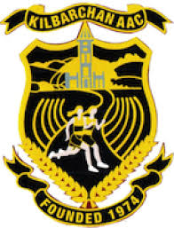
Any athlete or parent who has a grievance about team selection should discuss this with the relevant team manager. If this does not resolve the problem, the club’s Grievance Procedure should be followed.

