Kilbarchan aac
Version 0.1
Season 2019-20
Code of Conduct for all

We ask all coaches, athletes, team managers, volunteers, parents/guardians/carers and supporters of Kilbarchan AAC to abide by the following:

- Act with dignity and display courtesy and good manners towards others

- Challenge inappropriate behaviour and language by others

- Not carry or consume alcohol to excess and/or illegal substances.

- Avoid carrying any items that could be dangerous to yourself or others excluding athletics equipment used in the course of your athletics activity

- Respect the rights, dignity and worth of every athlete, coach, technical official and others involved in athletics and treat everyone equally

- Consistently promote positive aspects of the sport such as fair play and never condone rule violations or the use of prohibited or age-inappropriate substances

- Avoid swearing and abusive language and irresponsible behaviour including behaviour that is dangerous to yourself or others, acts of violence, bullying, harassment and physical and sexual abuse

- Avoid destructive behaviour and leave athletics venues as you find them

- Never engage in any inappropriate or illegal behaviour

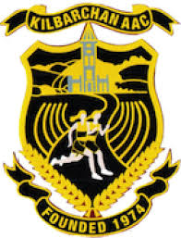
- Cooperate fully with others involved in the sport such as coaches, technical officials, team managers, doctors, physiotherapists, sport scientists and representatives of the governing body in the best interests of the athlete

